Document Release Status

**Draft**

|  |  |
| --- | --- |
| Release Date | Version |
| 2017-11-29 | 1.0 |

**XYP APA 系统对轮速脉冲信号的性能要求**

|  |  |  |  |  |
| --- | --- | --- | --- | --- |
|  | Doucument Name  **XYP APA System Performance Requirements to EPS module** | | | |
|  | Document Type | | | |
| Owner Domain：Document Prefix | | | |
| Doucement No | Revision  **1.0** | Volume No | Page No  **1(8)** |

Document Release Status

**Draft**

|  |  |
| --- | --- |
| Release Date | Version |
| 2017-11-29 | 1.0 |

**Revision history**

|  |  |  |  |  |  |  |  |  |  |  |  |
| --- | --- | --- | --- | --- | --- | --- | --- | --- | --- | --- | --- |
|  | **Previous** |  |  |  | **Current** |  |  | **Version Description** | **Responsible** | **Date** |  |
|  | **Version** |  |  |  | **Version** |  |  |  |  |  |  |
|  |  |  |  |  |  |  |  |  |  |
|  |  |  |  |  |  |  |  |  |  |  |  |

Draft

V1.0

**Change log**

|  |  |  |
| --- | --- | --- |
| **Release** | **Section** | **Change Description** |
|  |  |  |
|  |  |  |

|  |  |  |  |  |
| --- | --- | --- | --- | --- |
|  | Doucument Name  **XYP APA System Performance Requirements to EPS module** | | | |
|  | Document Type | | | |
| Owner Domain：Document Prefix | | | |
| Doucement No | Revision  **1.0** | Volume No | Page No  **2(8)** |

Document Release Status

**Draft**

|  |  |
| --- | --- |
| Release Date | Version |
| 2017-11-29 | 1.0 |

**Contents**

**1** **INTRODUCTION****4**

**1.1****SCOPE OF DOCUMENT****4**

**1.2****REFERENCE DOCUMENT****4**

**1.3****ABBREVIATION****4**

**2** **轮速脉冲信号更新频率****5**

**3** **车轮转动单圈脉冲数****5**

**4** **轮速脉冲信号精度****5**

**5** **车轮转动方向信号****7**

|  |  |  |  |  |
| --- | --- | --- | --- | --- |
|  | Doucument Name  **XYP APA System Performance Requirements to EPS module** | | | |
|  | Document Type | | | |
| Owner Domain：Document Prefix | | | |
| Doucement No | Revision  **1.0** | Volume No | Page No  **3(8)** |

Document Release Status

**Draft**

|  |  |
| --- | --- |
| Release Date | Version |
| 2017-11-29 | 1.0 |

**1** **Introduction**

**1.1** **Scope of Document**

This document specifies TTE APA system performance requirements to EPS module for SEM DX7.

**1.2** **Reference document**

Table 1.2.1 lists the reference documents.

**Table 1.2.1**: Reference

|  |  |  |  |  |  |  |  |  |
| --- | --- | --- | --- | --- | --- | --- | --- | --- |
|  | **Reference** |  | **Source** | **Title** | **Version or date** | **Document** |  |  |
|  | **Num** |  |  |  |  | **Number** |  |  |
|  |  |  |  |  |  |  |
|  |  |  |  |  |  |  |  |  |
|  |  |  |  |  |  |  |  |  |
|  |  |  |  |  |  |  |  |  |
|  |  |  |  |  |  |  |  |  |
|  |  |  |  |  |  |  |  |  |

**1.3** **Abbreviation**

.Table 1.3.1 lists the reference words.

**Table 1.3.1:** Abbreviation

|  |  |
| --- | --- |
| **Acronyms** | **Description** |
|  |  |
|  |  |
|  |  |
|  |  |
|  |  |
|  |  |
|  |  |

|  |  |  |  |  |
| --- | --- | --- | --- | --- |
|  | Doucument Name  **XYP APA System Performance Requirements to EPS module** | | | |
|  | Document Type | | | |
| Owner Domain：Document Prefix | | | |
| Doucement No | Revision  **1.0** | Volume No | Page No  **4(8)** |

Document Release Status

**Draft**

|  |  |
| --- | --- |
| Release Date | Version |
| 2017-11-29 | 1.0 |

1. **轮速脉冲信号更新频率**

APA系统在寻找车位时的速度上限是30 km/h，在进入泊车引导之后的速度上限一般为8 km/h

或者10 km/h。为了满足在整个速度门限范围内，APA都能准确定位车辆位置，需要轮速脉冲信号

能有较高的更新频率，即较短的发送周期。

轮速脉冲的发送周期必须小于等于20ms，我们期望的发送周期为10ms。

1. **车轮转动单圈脉冲数**

APA系统定位车辆位置主要是通过方向盘和车辆行驶距离来定位。而车辆行驶距离是通过

ABS发送的轮速脉冲个数计算得来的。假设车轮的周长为定值，当每个轮子转动一圈的脉冲数越

大，则单个脉冲所表示的行驶距离就越小，即车辆定位精度就越高。

车轮转动单圈脉冲数必须大于等于48，如果能达到96个会更好。

1. **轮速脉冲信号精度**

在对于轮速脉冲的精度进行标定确认时，我们主要会采用两种方式，一是连续单圈测试法，

即在确保车辆基本沿直线行驶的前提下，当车轮连续完成一圈的转动后停止一段时间，然后再按

该方式连续转动，具体请参考图 1（轮速脉冲计数值随时间变化图像）。

另一种方式是断续单圈测试法，与方式一区别在于在完成一轮的转动过程中采用“起停起

停”的间断转动方式，具体请参考图 2。

|  |  |  |  |  |
| --- | --- | --- | --- | --- |
|  | Doucument Name  **XYP APA System Performance Requirements to EPS module** | | | |
|  | Document Type | | | |
| Owner Domain：Document Prefix | | | |
| Doucement No | Revision  **1.0** | Volume No | Page No  **5(8)** |

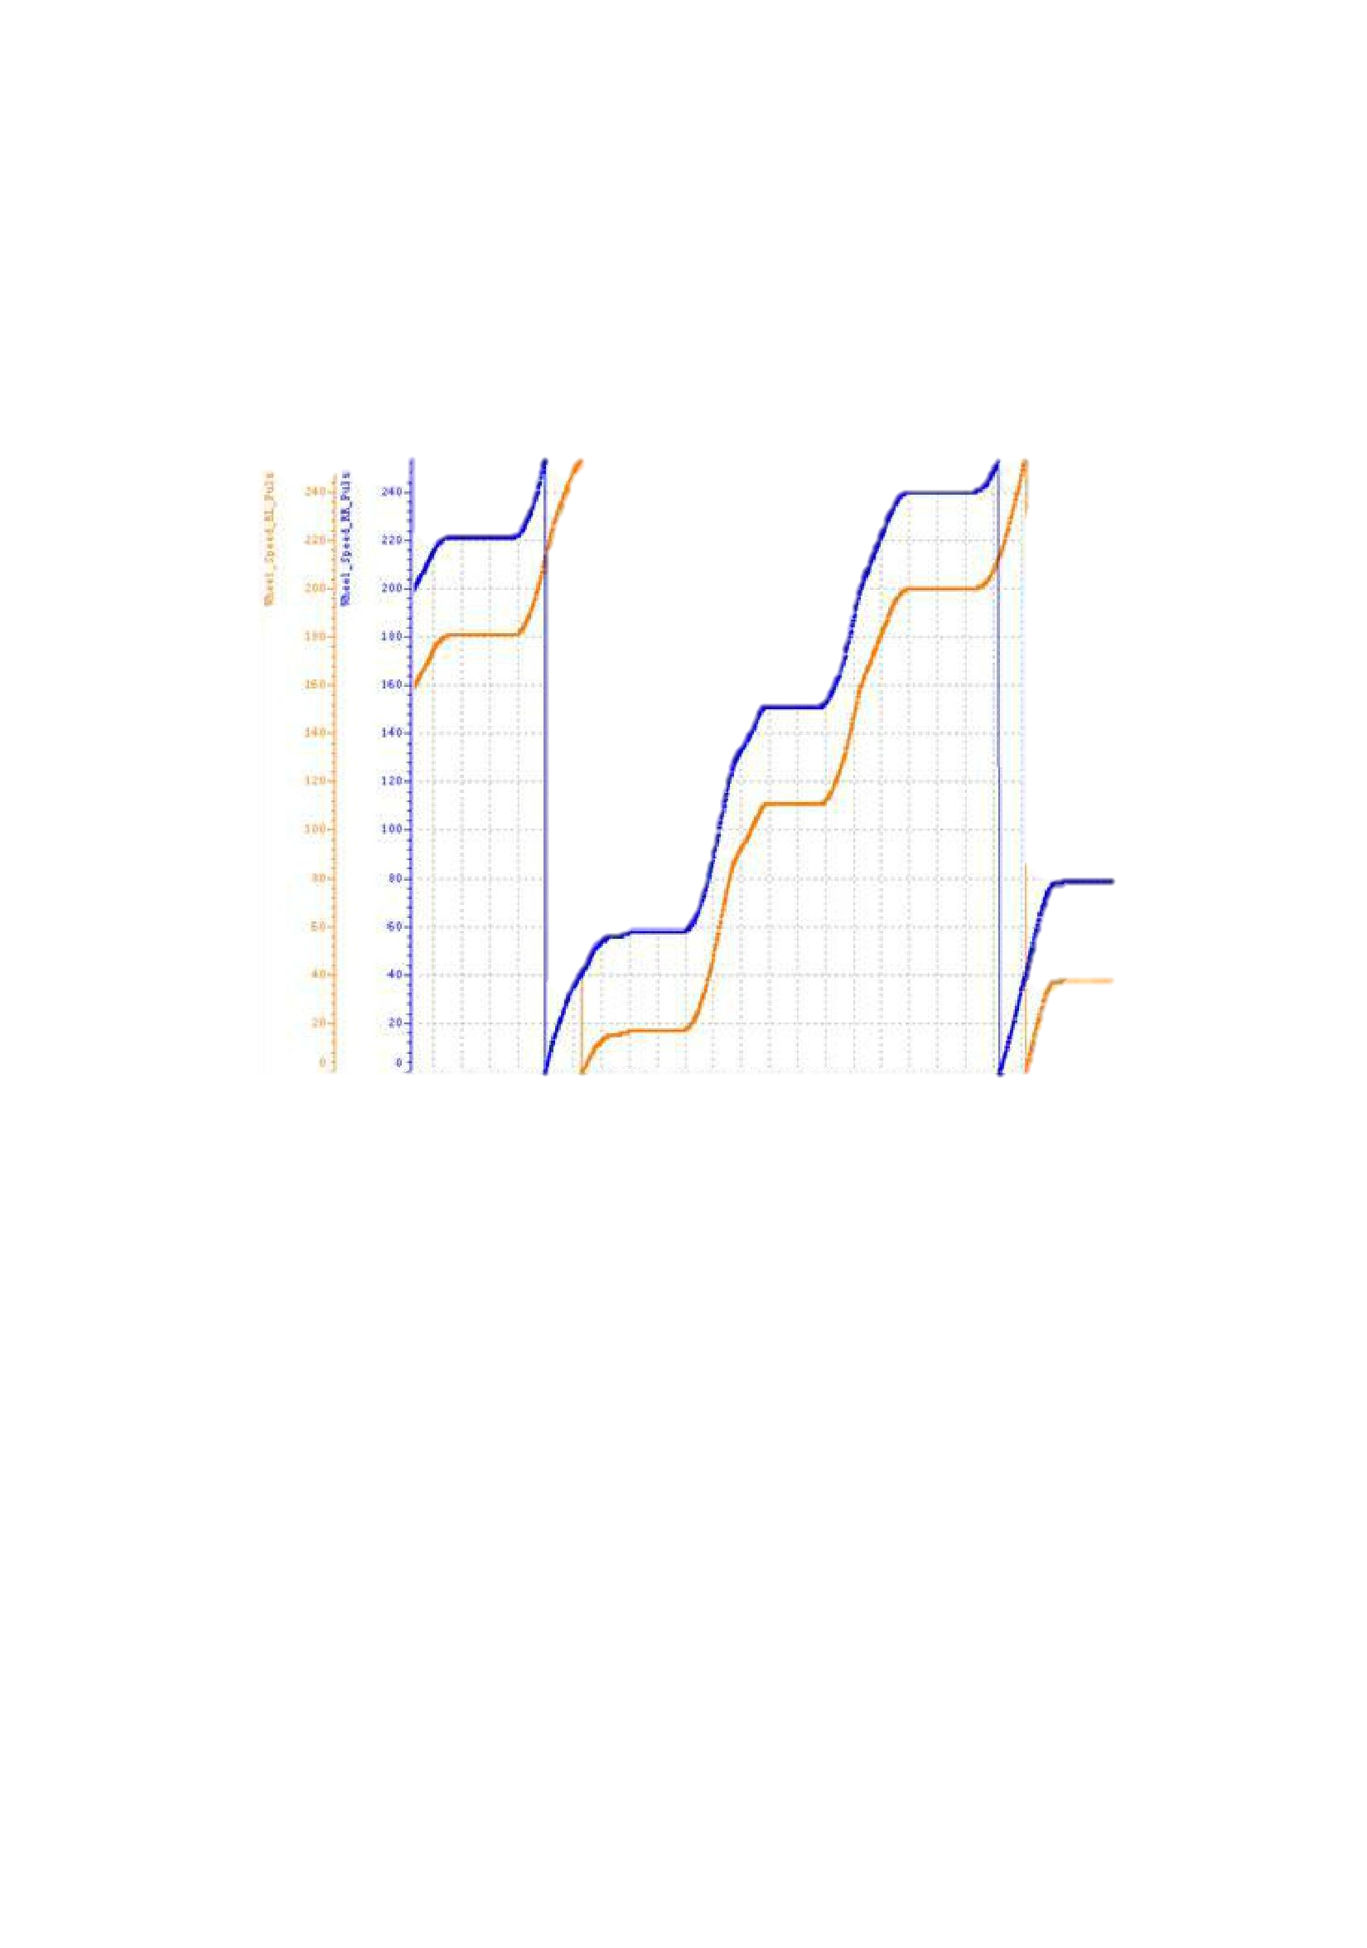Document Release Status

|  |  |  |
| --- | --- | --- |
|  | **Draft** |  |
|  |  |  |
|  | Release Date | Version |
|  | 2017-11-29 | 1.0 |
| 图 1 和图 2 为车轮的脉冲计数值随时间变化的图像，蓝色和橙色线分别表示两个轮子的实时 | | |

脉冲值。

图 1 连续单圈测试法

|  |  |  |  |  |
| --- | --- | --- | --- | --- |
|  | Doucument Name  **XYP APA System Performance Requirements to EPS module** | | | |
|  | Document Type | | | |
| Owner Domain：Document Prefix | | | |
| Doucement No | Revision  **1.0** | Volume No | Page No  **6(8)** |

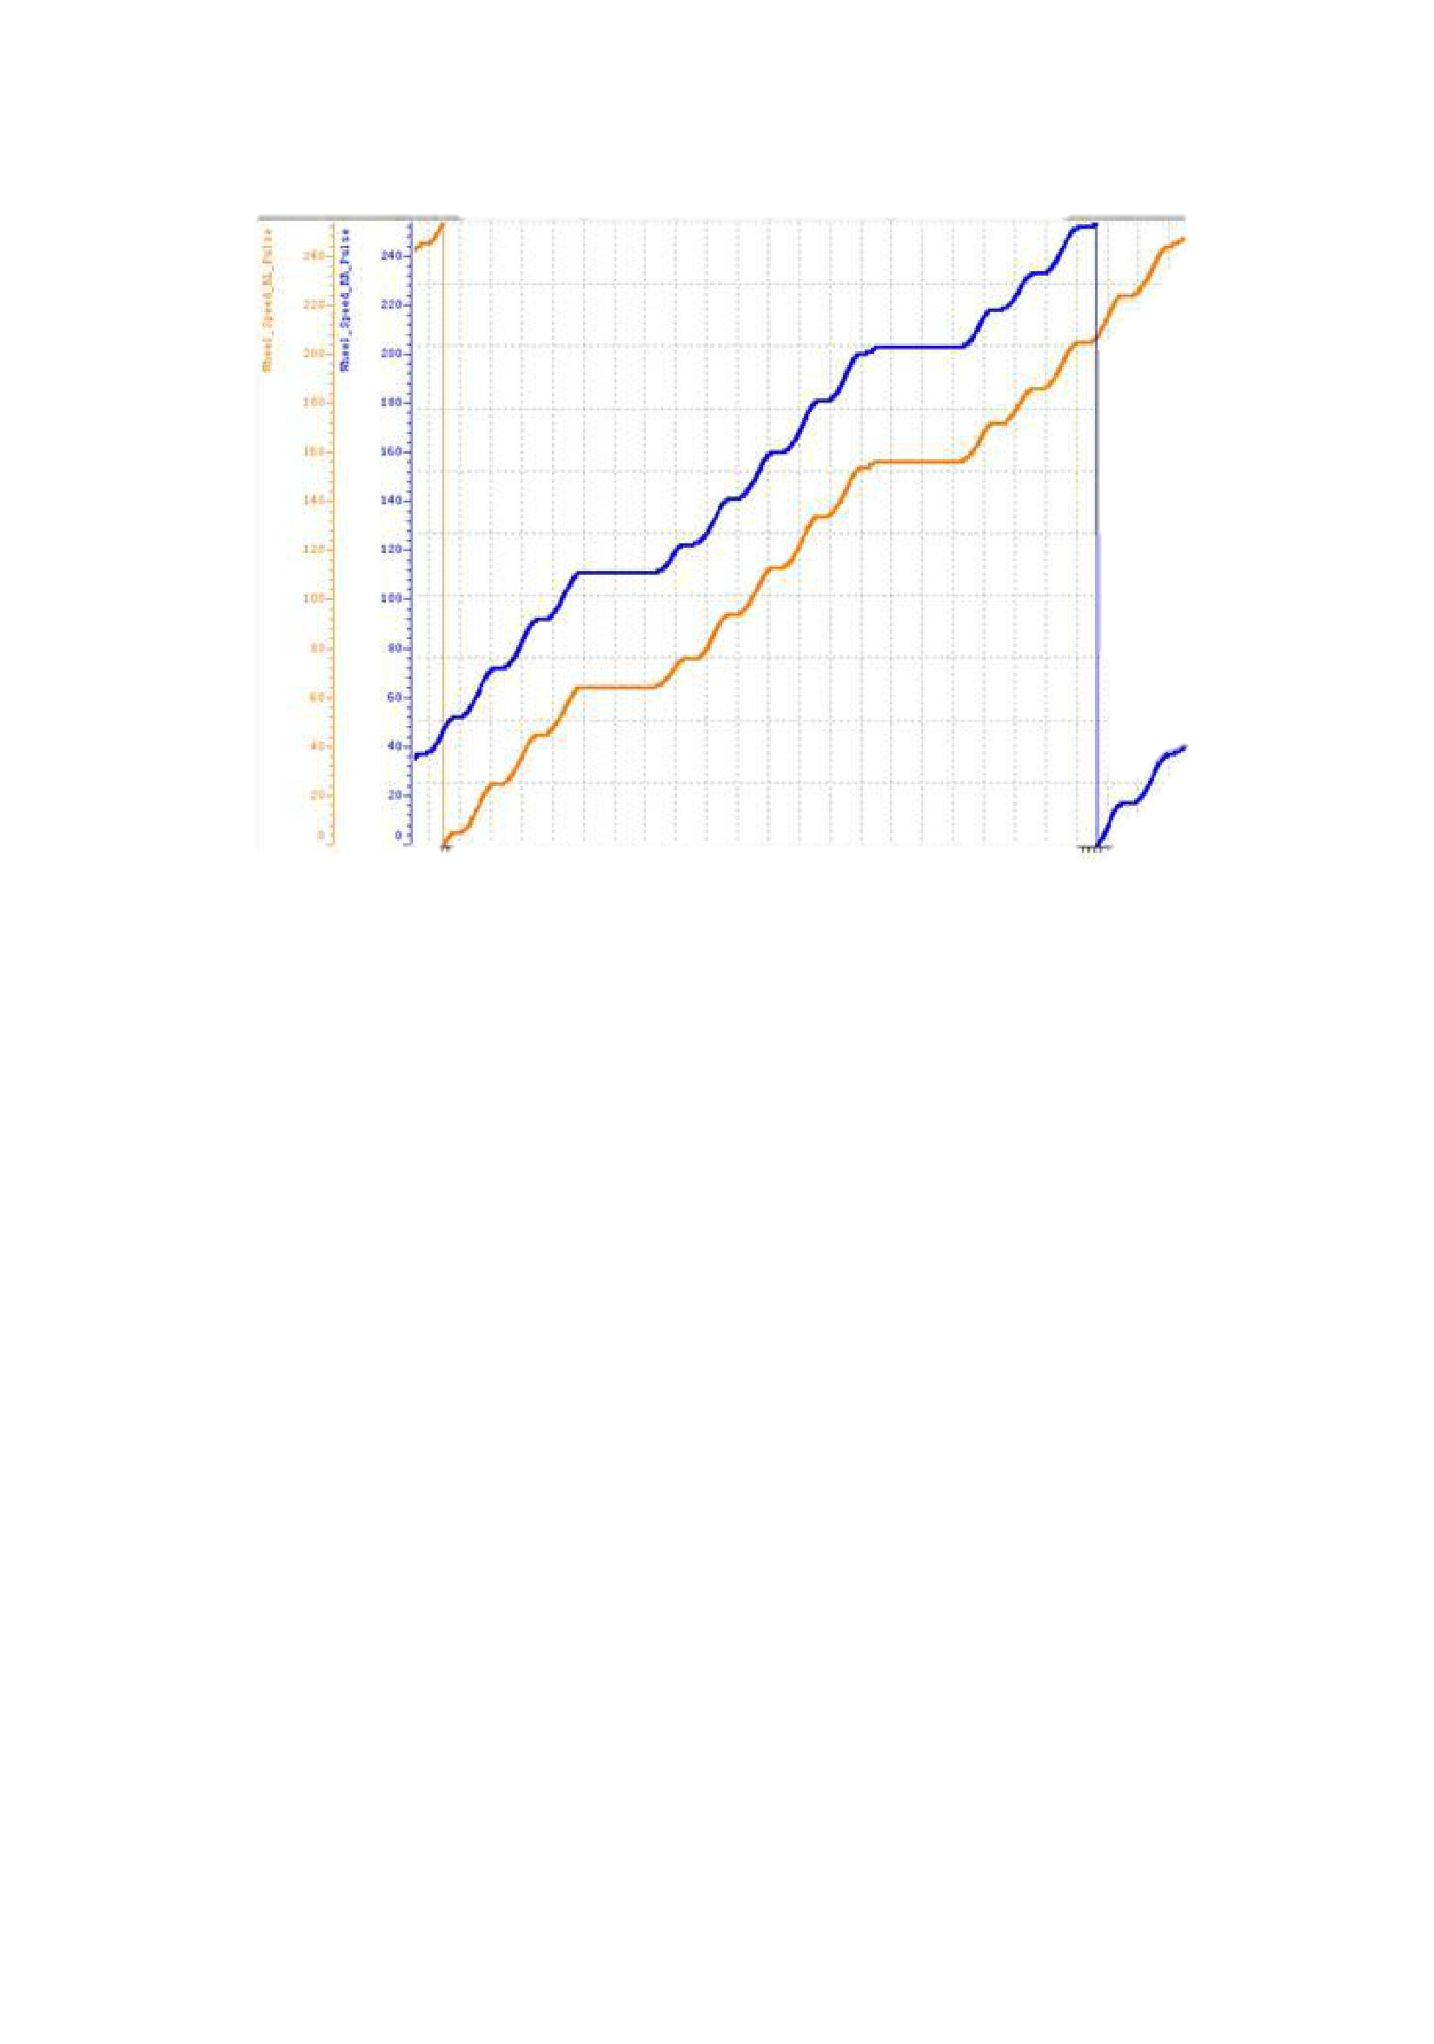Document Release Status

**Draft**

|  |  |
| --- | --- |
| Release Date | Version |
| 2017-11-29 | 1.0 |

* 2 断续单圈测试法

通过这两种方法进行测试，要求所测得的单圈脉冲偏差值必须在一定范围内，具体对应关系请参考下

表：

单圈轮速脉冲设计值 容差

|  |  |  |
| --- | --- | --- |
| 48 ≤ N < 72 | | ±1 |
|  |  |  |
| 73 ≤ N < | 96 | ±2 |
|  |  |  |
| N ≥ 96 |  | ±3 |

1. **车轮转动方向信号**

在默认情况下，APA 系统会通过档位信号来判断来判断车辆的行驶方向。但在某些特殊情况下，如车辆后

溜，驾驶员在车辆没有完全静止的情况下切换档位等，都会出现车辆行驶方向和档位所指示的方向不一致。这将导致

APA 最终泊车的效果不佳，甚至直接影响的功能。

|  |  |  |  |  |
| --- | --- | --- | --- | --- |
|  | Doucument Name  **XYP APA System Performance Requirements to EPS module** | | | |
|  | Document Type | | | |
| Owner Domain：Document Prefix | | | |
| Doucement No | Revision  **1.0** | Volume No | Page No  **7(8)** |

Document Release Status

**Draft**

|  |  |
| --- | --- |
| Release Date | Version |
| 2017-11-29 | 1.0 |

因此，如果能够提供车轮转动方向信号的话，APA 可以直接通过该信号来判断车辆的行驶方向，这样就能够使得 APA 能够更准确的判断车辆的运动轨迹，从而实现较为理想的泊车效果。

|  |  |  |  |  |
| --- | --- | --- | --- | --- |
|  | Doucument Name  **XYP APA System Performance Requirements to EPS module** | | | |
|  | Document Type | | | |
| Owner Domain：Document Prefix | | | |
| Doucement No | Revision  **1.0** | Volume No | Page No  **8(8)** |